Slack Business Case

Month YYYY
Written by
[Author(s)]

Table of Contents
Executive Summary 2
What Problems Are We Solving? 3
Return on Investment 4
Implementation Plan 5
Rules of Engagement and Governance 6
When to use Slack and what to use it for: 6
What to avoid using Slack for: 6
Extensibility 8
Internet of Things – Machine Interaction 9
Breaking Down Information Silos 10
Financial 11
Fair billing policy 11
Cost Estimate 11
Sources 12

Executive Summary

Persistent Chat can be seen as an evolution of how teams communicate and collaborate with each other. With the advent of an increasingly remote and globally diverse workforce, the need to communicate quickly and efficiently is paramount.
Email is widely used as a standard business communication tool, specifically as it relates to working across company lines. However, the use of email, especially internally, has been construed as a “chat” tool, when that was never it’s intended purpose. As such, we end up spending enormous amounts of time reading, organizing, and responding to email. With the need to quickly respond to each other and answer questions quickly and efficiently, email does and will not fit the bill as a viable solution to scale for this purpose. Additionally, email does not allow us to easily and quickly form affinity groups or teams, yet this is how the majority of us operate.
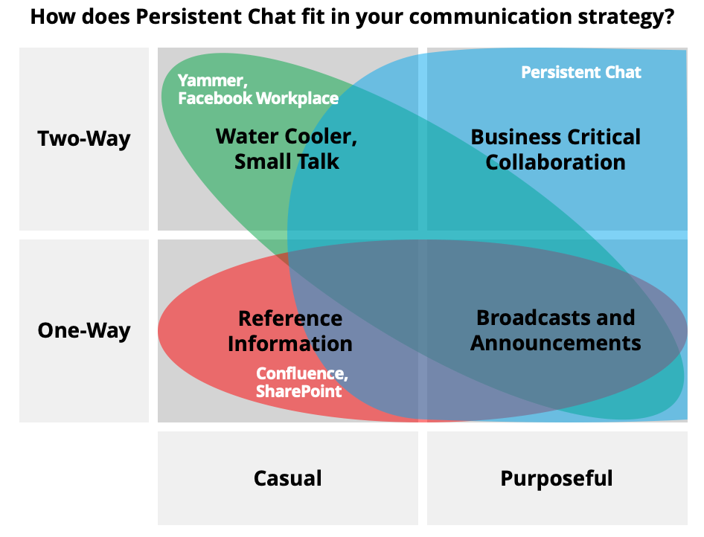
Social networks for the enterprise, such as Yammer, served a purpose but are also not a viable solution for quick chat collaboration (not real-time). Consider the chart to the right. Yammer has a narrow impact between two-way conversation and one-way broadcasts. It does not support business critical collaboration or information storage very well. SharePoint on the other hand does not support two-way communication at all. Persistent chat is an evolution that bridges one-way, two-way, casual, and purposeful communication streams within a single solution.
Investigation of tool convergence shows other solutions are not as capable. Slack enables us to leverage our technical capabilities, such as IoT, via ChatOps.
"ChatOps is a collaboration model that connects people, tools, process, and automation into a transparent workflow. This flow connects the work needed, the work happening, and the work done in a persistent location staffed by the people, bots, and related tools." - Sean Regan, Hipchat
Over time, the history our company builds in Slack will serve as our digital brain containing decisions, important information, team history, and stories about our culture. No other tool can do this. Bridging the gaps between company lines with a tool like Slack, yet maintaining security and control, is entirely possible with this platform. The benefits of working together seamlessly across company lines can be an incredible benefit.
In fact, we are already seeing usage of Slack increase inside our own company walls as well as outside. For example, [XYZ] team is using it for their team collaboration. [Company] has included Slack on their roadmap for adoption in the near future. Other clients, such as [Customer A] and [Customer B] have requested to collaborate with us via Slack.
This document describes in detail the business case made for implementing Slack. Specifically addressing cost-benefit, use cases, implementation steps and basic guidelines for use.

What Problems Are We Solving?
- Reduce amount of time spent checking and responding to email
- Reduce amount of time spent in meetings
- Officially adopt a technology that is already widely used
- Improve employ efficiency overall by creating channels to support better daily team collaboration (Ex: Team channels, private project channels, affinity group and culture channels, and direct messaging)
- Improve business critical collaboration (Ex: Escalations) by quickly bridging together our employees, customers and vendors
In evaluating this solution, we will seek to provide consulting, best practices, implementation, and training as service offerings to prospective clients

Return on Investment
It is difficult to measure with precision the amount of time and money saved by improving employee efficiency. We do not have a baseline in place with which to compare such measures. In order to estimate our return on investment, we will look at the costs associated with managing email and attending meetings.
A study conducted by McKinsey & Company in 2012 revealed that works spend more than 25% of their day reading and responding to email. At [Our Company], this number is likely higher due to our field and nature of work. Based on a survey conducted by Slack in 2015, Slack was able to, on weighted average, reduce internal email by 48%. Let’s assume conservatively that we spend 12.5% of our time on email. If we reduced this down to 6.5% for 200 employees, we would create a balance of 23,000 hours per year that could be repurposed for billable or other strategic activities.
Meetings are another source of waste that Slack claims to reduce by, on weighted average, 25%. As an example, consider the cost of an average one-hour weekly team meeting for an 8-person team. Assuming the average cost of a FTE is approximately $65/hour, one team meeting costs $520. Hold these meeting 48 times per year, the cost is approximately $24,960 for one team. If we were able to reduce those by 25% to 36 meetings per year, we would save $6,240 per team.
As we grow larger, we must grow smaller. Slack is uniquely positioned to create a sense of smaller, more close-knit teams, even though our team sizes may grow larger and more geographically diverse.

Implementation Plan
Slack has grown organically and is consistently seeing increased usage on a weekly basis. To some extent, the implementation of Slack has already organically occurred.
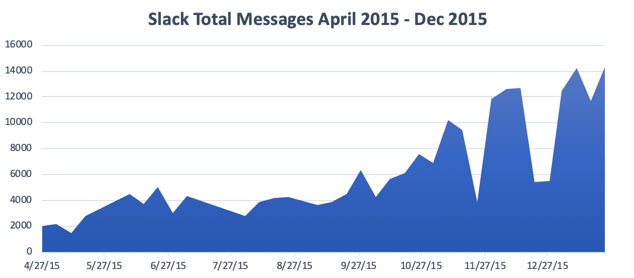
The following steps outline a high-level implementation strategy:

- Define Governance Plan. Review information management policy and define Slack’s usage guidelines. Clearly define what data is acceptable and unacceptable. Also need to clarify Slack is not a substitute for tickets and information that should be captured in tickets needs to be record in ServiceNow.
- Risk Assessment
- Training Plan & Slack Ambassadors
- Purchase Accounts/Go-live

Rules of Engagement and Governance
This section defines the rules and scope of use of Slack as a persistent chat tool with [Our Company]. Existing Policy, Standards, and Procedures documented must be followed with the use of Slack and any of its supporting or integration components. This includes, but is not limited to, Acceptable Use Policy, Privacy Policy, etc. Sensitive data and Intellectual Property should not be stored or uploaded to Slack. Examples of this would be passwords, HIPAA, and PCI-DSS data. Refer to our existing Data Classification and Information Management standards on appropriate locations for housing and distributing data.

When to use Slack and what to use it for:
- Hashing things out quickly - Channels provide a way to quickly hash things out as a team. Things like this are much better served in a channel as opposed to email. Things you might normally address in a meeting room may also qualify as something that can be addressed in channels.
- Project chat and collaboration - Project-focused channels are a great way to create a common space for teams to communicate together about a project they're working on. Quickly hashing out ideas, addressing issues, keeping up with the pulse of your clients/industry (RSS integration, for example), all help to create a better project delivery experience.
- Escalation rooms - When things go horribly wrong, you need to get people on the same page quickly. More importantly you need a common space where you can keep people informed and work with each other in a close-knit environment through issue resolution.
- Team meetings - Slack allows users to create more than just one-line messages. You can also create posts. Posts can contain to-do lists. These are great for running your weekly team meetings and keep folks accountable with action items. The history is also preserved and searchable over time.
- Bridge the gaps between remote employees, vendors and clients - Channels can be created to make your team seem smaller and more localized.
- Direct messages - Similar to #1 above, sometimes you just need to hash something out quickly with another person. Or multiple people. Both can be done via direct messages (DM). This is similar to the existing functionality we have with Skype for Business, however, sharing files, images, code, links, etc. becomes much easier in Slack DMs.
- Audio/video calls and screen sharing - This feature can be used to augment the conversation when folks need to strike up a quick call or share their screens. All of this can be done right in-line with the current conversation using the /call function in Slack.

What to avoid using Slack for:
- Expectations for responding ASAP should not necessarily be expected.
  - We do not want to create an ASAP culture. Employees need time to focus and concentrate. Slack should not be viewed as something you need to check and respond to constantly. It should be something you check at regular, planned intervals. Create boundaries people understand and encourage common sense! However, it should be noted that some channels may require more attention than others. For example, the #random channel is not an area that you need to check on frequently as it has nothing particularly relevant to your job. But your project channel on the other hand is absolutely a channel that you should check and be prompt to respond to. The frequency and expectations around responsiveness is something each organization must consider and set the tone for.
  - There is a Do Not Disturb (DND) feature in Slack and users also have the ability to customize their notification settings on a channel by channel basis.
- Large decisions that have a significant impact on people in some way. Slack is likely not the best place to hash out a very large and complex problem. We recommend long-form messages or documents to share ideas that require thinking before responding. For this, email is a great tool.
- Presence and expectations - It should not be assumed that someone should respond to your chat message immediately. Everyone has their own schedule and the need to be focused on their work. Be courteous and respectful of this fact, regardless of the means you're using to chat with them.
- Implied consent - Just because you get 3 people to agree in a channel and the other 5 don't chime in doesn't mean you have consent. Some decisions still need to be formalized in some manner. However, smaller decisions with less impact may be just fine. We should follow our current standards for change management. Further, a manager or team lead should always document important decisions and disseminate them in a way that ensures everyone is informed and has a chance to respond with their questions, thoughts, and concerns. Again, email is a great tool for this sort of thing.
- Slack is not a substitute for other official systems of record. Any information that is normally captured within an appropriate system of record must continue to be captured as part of our normal operating procedures.

Extensibility
"The idea is to turn Slack into a “command center” that connects with other cloud business software. “We want to help more developers make a bet on the Slack platform,” said April Underwood, a former Twitter executive who joined Slack in June to craft its partnership strategy.
In our current state we're limited to our integration capabilities but we're already seeing a lot of user adoption. RSS feeds help getting information delivered to those needing it in a timely manner, in two cases of vulnerabilities we knew about issues nearly instantly and were able to provide knowledge to our customers as they contacted us in short order after. The built in /remindme feature provides individuals, teams and project managers with tools to drive actionable follow up. Likewise, the built-in post method is what enabled a private message group to collaborate on this very document!
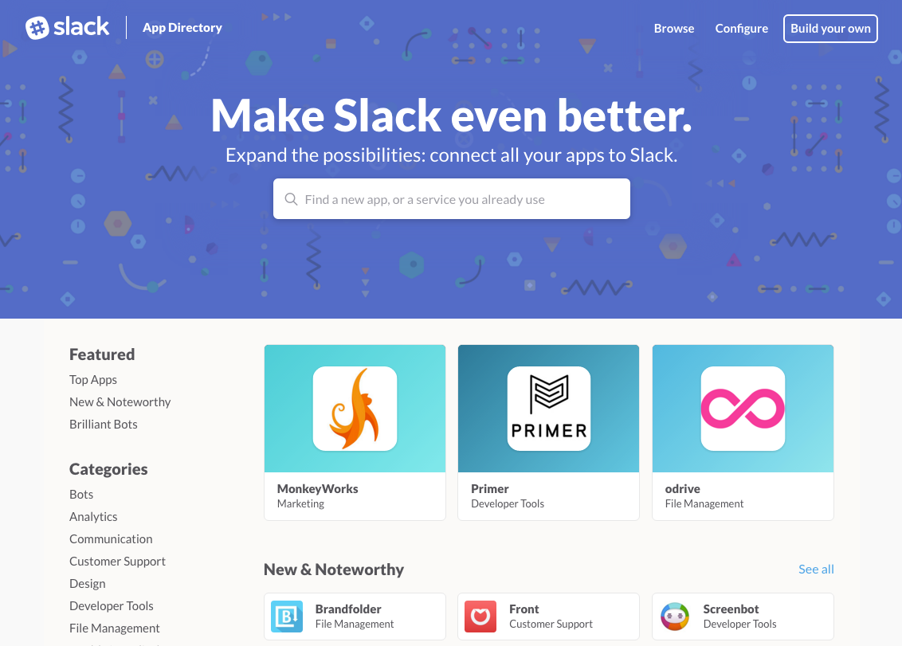
There has even been discussion during the [Project] design session of benefits of integration of Slack with [Product/Project]. To have inline topical conversation from directly in the app might deliver a lot of value that helps differentiate us from our competition. Alternatively, the ability to access and interact with [Product] directly from the chat line provide team visibility to actions taken. It’ll be much harder for onboarding clients or entities in snooze to catch a team by surprise!

Internet of Things – Machine Interaction
The driving power behind the latest buzzword is the general idea that we can leverage technology to do as much work as possible autonomously, invoking human interaction when necessary in a way both respectful to their preferences and time. Slack provides a common, easy interface to do just that, lending to the birth of ChatOps.
"ChatOps is a collaboration model that connects people, tools, process, and automation into a transparent workflow. This flow connects the work needed, the work happening, and the work done in a persistent location staffed by the people, bots, and related tools."
- Sean Regan, Hipchat
Our adoption is just starting but the rate of user adoption demonstrates demand. Our internal source version control system made an early appearance on Slack, allowing project authors to determine the relevant content and context. Users of Slack get notified of changes to projects they are interested in. Visibility of valuable projects that might have gone unnoticed before is greatly increased. We've seen users merge projects to collaborate on single code bases, and new users getting involved in projects weekly.
Teams and users get notifications of critical data to their teams’ performance with relevant information to assist in taking action. Due to the customizable nature of message delivery, the amount of noise generated is tailored to the individual need. Some individuals or teams enjoy seeing everything going on to keep people on the same page as others prefer only actionable and critical incidents are surfaced.
These examples are just the start, the sky is limited by our own demand and policy. Do we want to be able to take action on remote hosts from the chat line? It'd be great for learning, team knowledge, peer review, but perhaps it’s too much noise, or we don't want to interconnect direct action on hosts from chat. These are decisions that will need to be considered and made as we encounter them but having the power and flexibility to pursue them is advantageous.
Connecting "the work needed, the work happening, and the work done in a persistent location staffed by the people, bots, and related tools" is a goal in sight.

Breaking Down Information Silos
Slack is a path to break down barriers and empower the individual and the team. This facilitates continuous improvement.
We see opportunities for effective cross-team learning nearly daily on Slack as we tackle increasingly complex challenges and continuously improve our performance. Being able to maintain and nurture that knowledge in a persistent system with strong search functionality lets us recycle that effort and continue to grow upon it. We aren’t the only people who benefit. The customer wins from this dynamic as we align as a whole and together are better equipped to deliver value to them.
More access to information allows teams to work individually and cooperatively to continuously improve our processes. There is a persistent discussion available to interested parties that fights tribal knowledge and facilitates better delivery. We can store decision processes and options explored. Staff can come to the table more prepared. We collectively offer more value by exposing these critical details for consumption.

Financial
Slack offers 3 paid tiers. Standard, Plus and Enterprise.
The Standard plan costs $6.67/user/mo when paid annually. The same plan is $8/user/mo without an annual commitment.
The Plus plan contains everything in Standard, but adds additional functionality such as SAML SSO, 99.99% uptime guarantee, and 24/7 support with a 4-hour SLA. The Plus plan costs $12.50/user/mo when paid annually ($15/user/mo monthly).
The Enterprise plan contains everything in the Plus plan and, for example, federation across multiple teams, unified security, and compliance policies.

Fair billing policy
Slack only bills customers for what they use. If a user goes inactive, Slack will credit the account for the period that user is inactive. On an annual commitment, we estimate the number of users we think we need and pay that amount up front. Slack will review our account and automatically credit us for any inactive users. While we may pay a certain amount up front, we can know that we will only be paying for what is actually being used on a monthly basis.

Cost Estimate
For the purpose of this report, we will evaluate the Standard and Plus plan costs. There are 122 active users in our Slack account as of this report. We will use 200 as our active user count for the purpose of estimating costs below. This is to account for the majority of the company.
 | Standard | Plus | Enterprise
Price/user/mo (billed annually) | $6.67 | $12.50 | Custom pricing at 1000+ users
Price/user/mo (billed monthly) | $8 | $15
Annual cost for 200 active users | $16,008 | $30,000
Monthly cost for 200 active users | $1,600 | $3,000
Discount for paying annually | 17% | 17%

We expect paying for 200 accounts will allow us to support the entire company based on fluctuating usage.

Sources
- http://www.huffingtonpost.com/2012/08/01/email-workday_n_1725728.html
- http://www.inc.com/jayson-demers/how-much-time-do-your-employees-waste-at-work-each-day.html
- https://www.slack.com/results
- https://github.com/chef/devops-kungfu/blob/master/talk-notes.md
- https://blogs.atlassian.com/2016/01/what-is-chatops-adoption-guide/

